1st Grade Supply List
2022-2023

- 1 heavy duty plastic folder for homework that has “home” and “return to school” labeled inside
- 1, Two Pocket Folder (any color/design)
- 1 package of Ticonderoga pre-sharpened Pencils 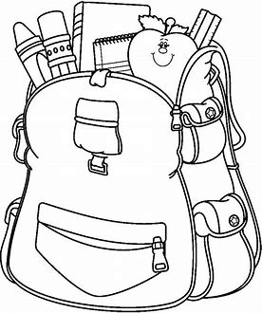
- 1 Plastic Pencil Box/Case
- 2 Erasers - Large Pink Block Erasers
- 24 Count Crayons
- 12 or 24 Count Colored Pencils
- 10 Count Markers
- 1 Pair Scissors (Kids, 5” blunt tip)
- Package of Glue Sticks
- 2 containers of “GREEN” disinfectant wipes
- 2 boxes of Tissues
- Hand sanitizer
- Headphones that can be used in a Chromebook (Put in a ziplock bag labeled with your child’s name)

**Extra pair of clothing to be kept in the classroom, labeled with your child’s name, in a ziploc bag. In case of accidents or spills**

